**Course Project: Booking a room in a motel (Due: Nov 30,2012)**

1. Main page:

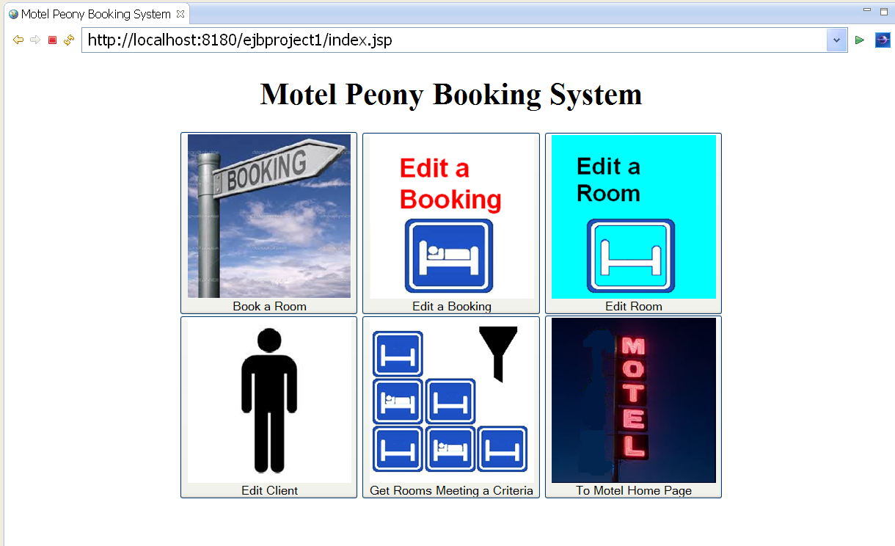

1. Add a booking: (I used jQuery to show the drop down calendar. I used javascript to check the start date and end date:
2. If start date is empty, ask user to enter a start date;
3. If start date is earlier than today, ask user to enter a start date NOT earlier than today;
4. If end date is empty, ask user to enter an end date;
5. If end date is earlier than today, ask user to enter an end date NOT earlier than today;
6. If end date is earlier than start date, ask user to enter an end date NOT earlier than start date.

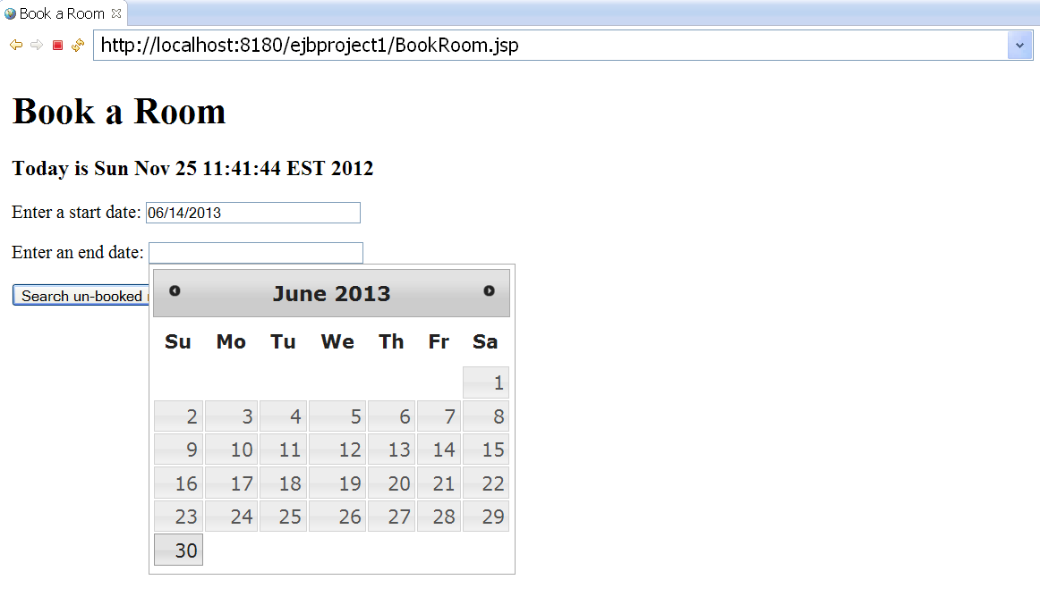

1. If user succeeded entering begin date and end date and clicked the “search” button, in the page user will find all the available rooms in this time period. User will need to choose one room from these list. Here I also used javascript to make sure that user’s input room number is from the room list.

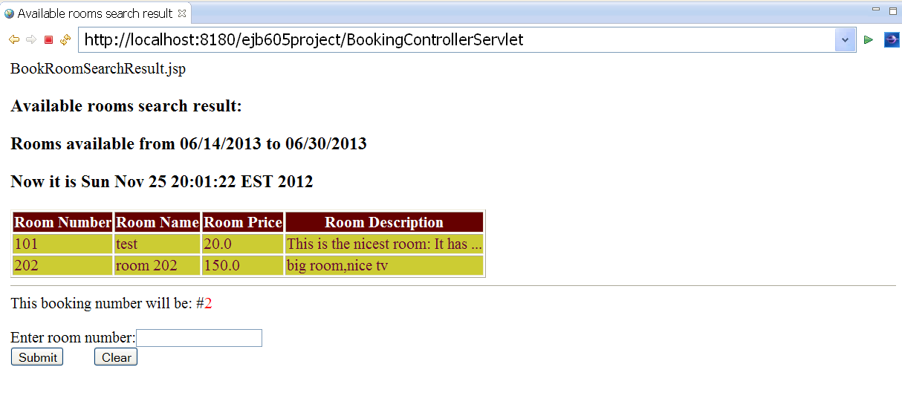

If user entered a wrong room number which is not on the room list, user will get an error message: “Please enter a room number in the table”:

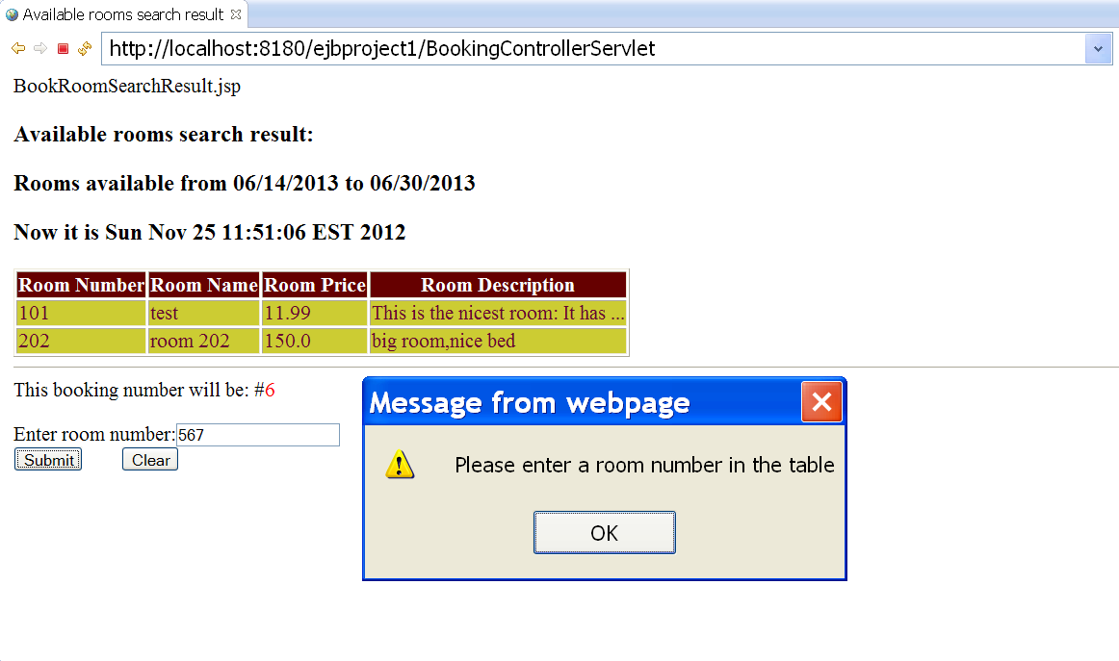

After user entered correct room number in the list and click submit button ,user will enter a page to register the booking. Notice that booking number and client ID are already automatically set by the system.

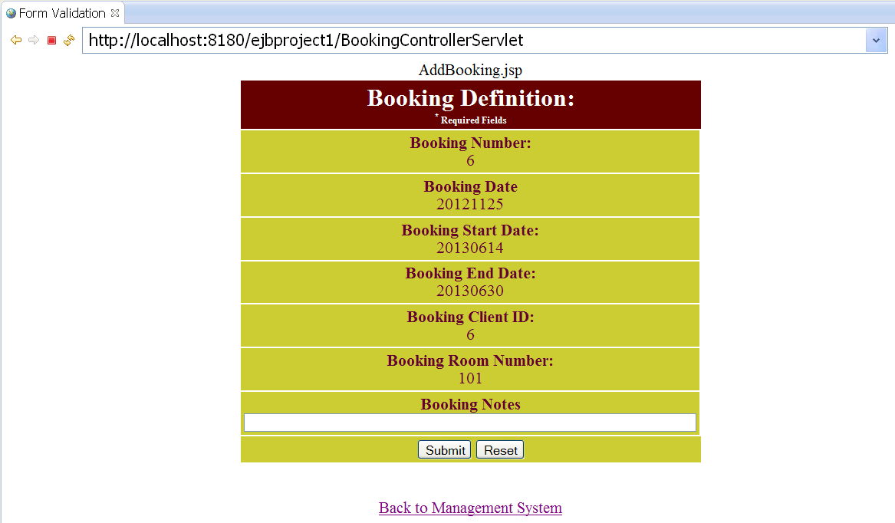

“Booking Notes” area is not a required field. So user can just click “submit” button to go to the next page to add a new client.

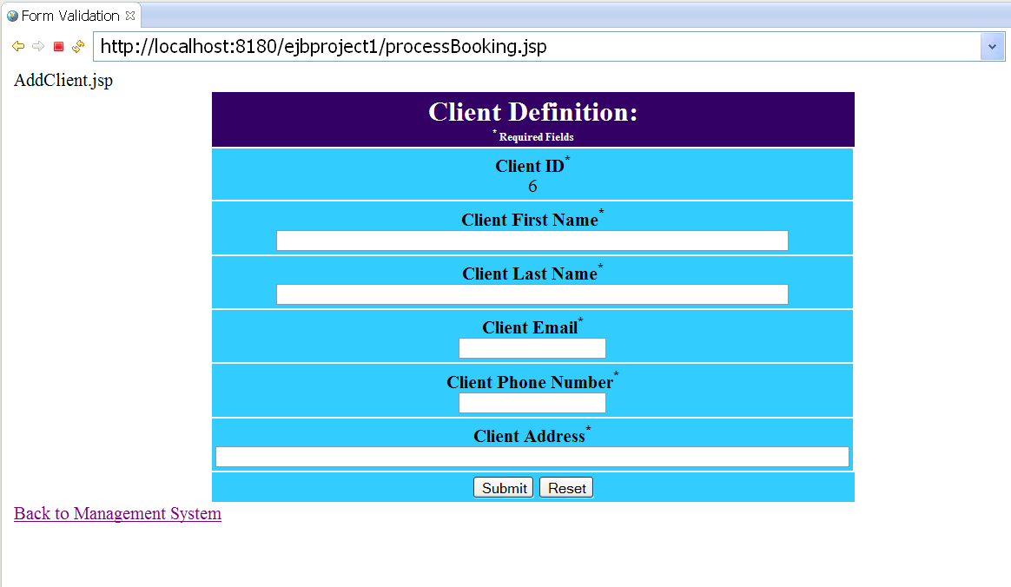

Notic here the client ID is automatically set to 6. “6” is (the current max client id ) + 1.

If the user forgot to enter some value, there will be error messages:

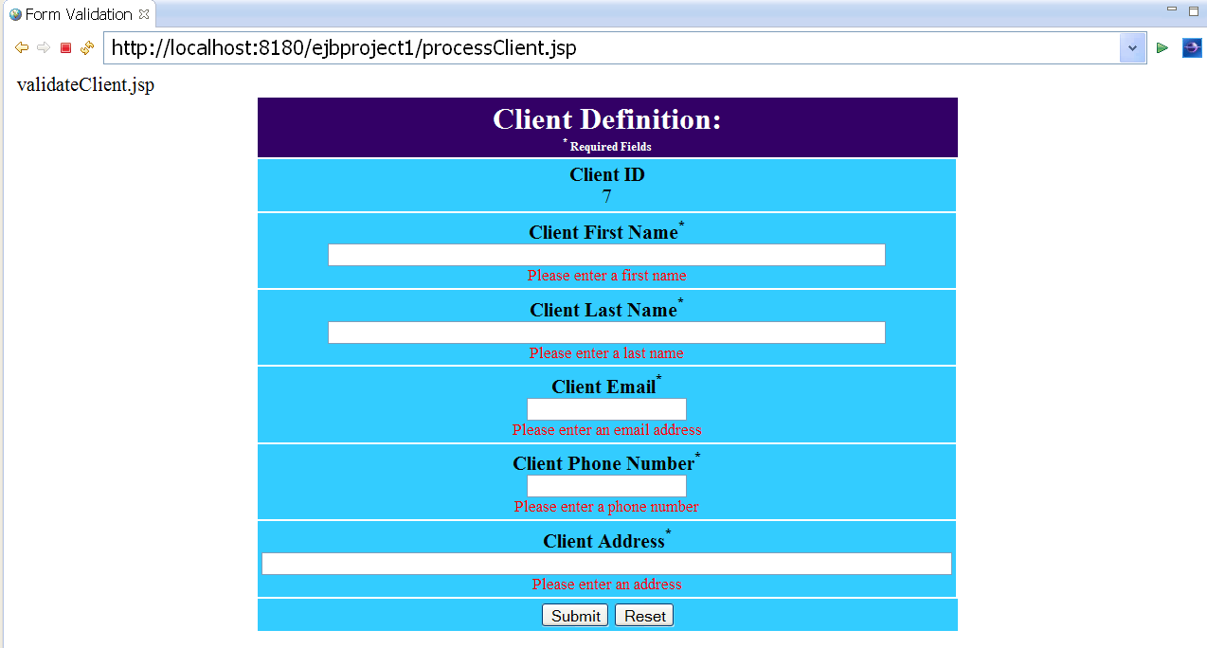

If a client id was deleted from the database, all other clients’ id will not be changed. You will see it in the next 4 screen shots.

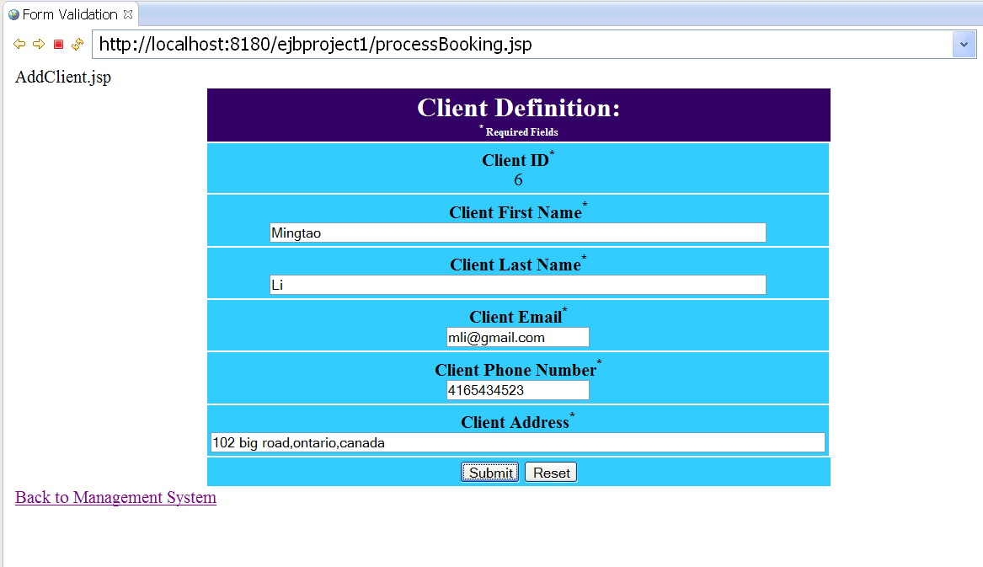

You can see the transaction was successfully done. In this transaction, a booking was added to the booking table. And a client was added to the client table.

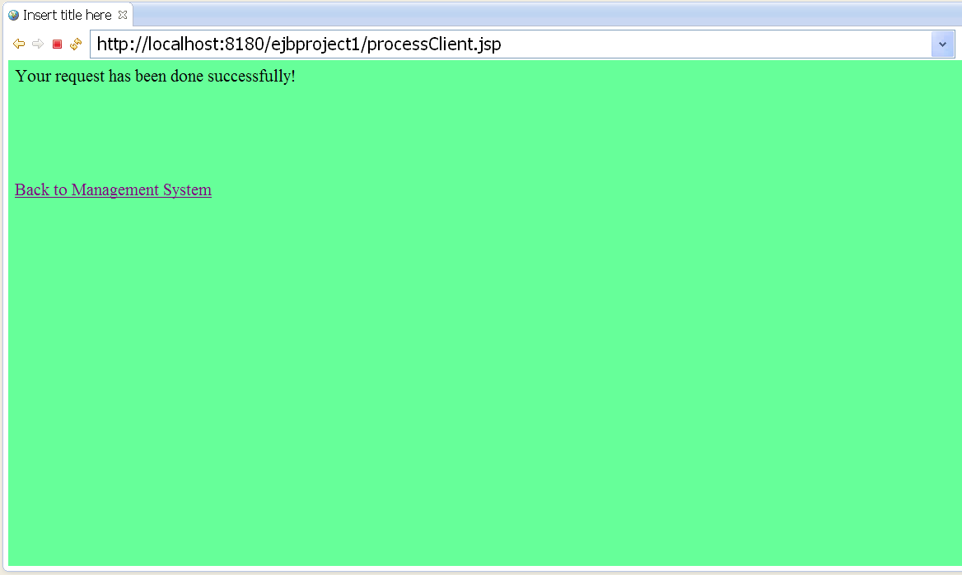

Now let’s check the client list. Go back to the main menu, click the big button with a person icon, next page choose “Get All”, then you will see the client list:

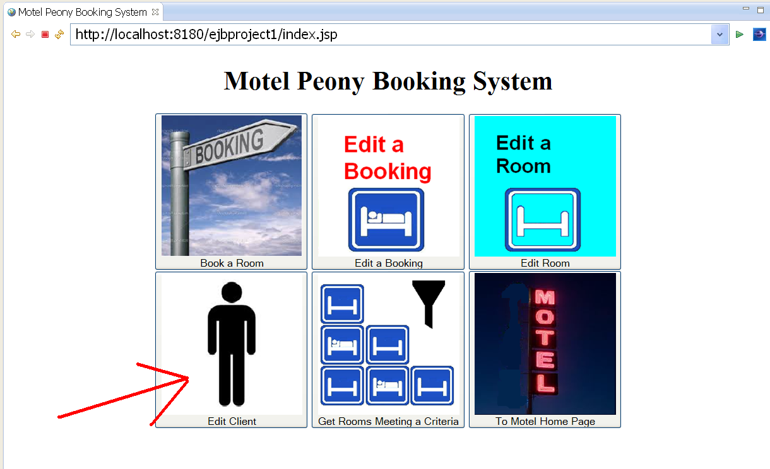

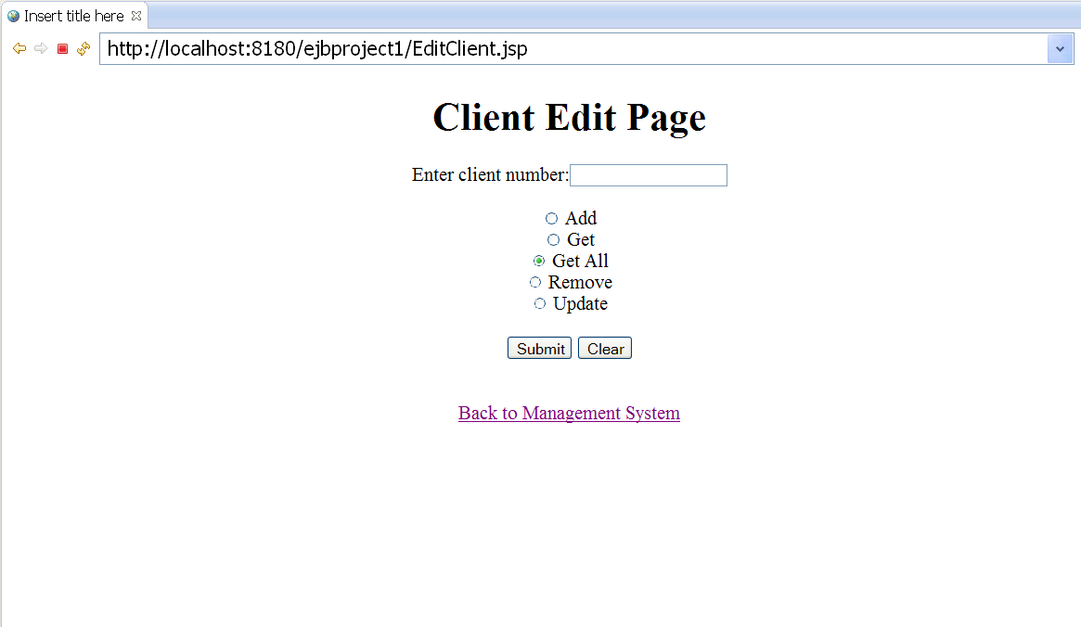

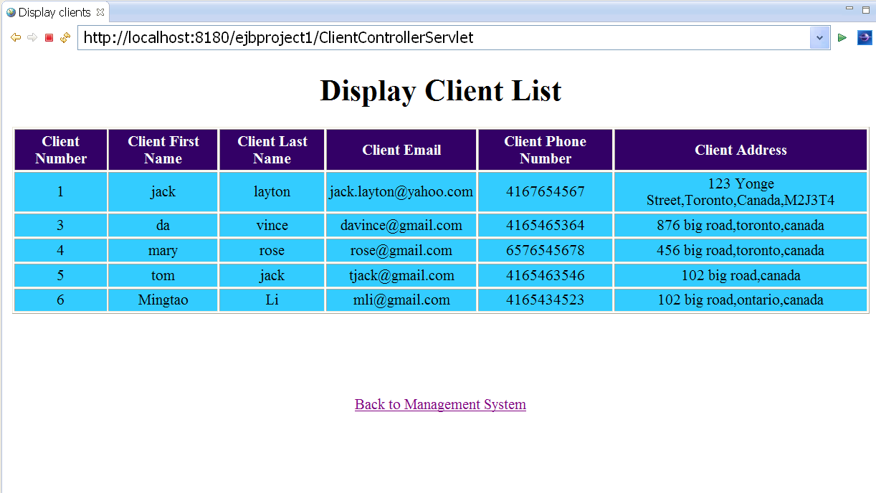

From the last screen shot, you can see all the client list. Notice that client ID #2 was deleted by me on purpose for this demonstration. After client #2 was deleted, when I tried to add a new client “Mingtao Li”, the client number (client ID) for this new client will be 6, not 5! This is done by a java code I wrote in java file: RoomControllerServlet. Here is the code:

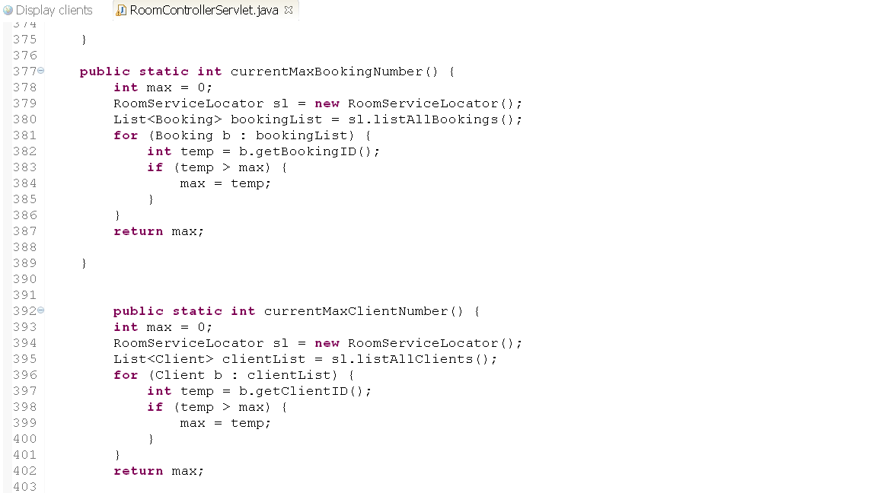

At the same time, a new booking record (booking number 6) was added to the booking table in MySQL database:

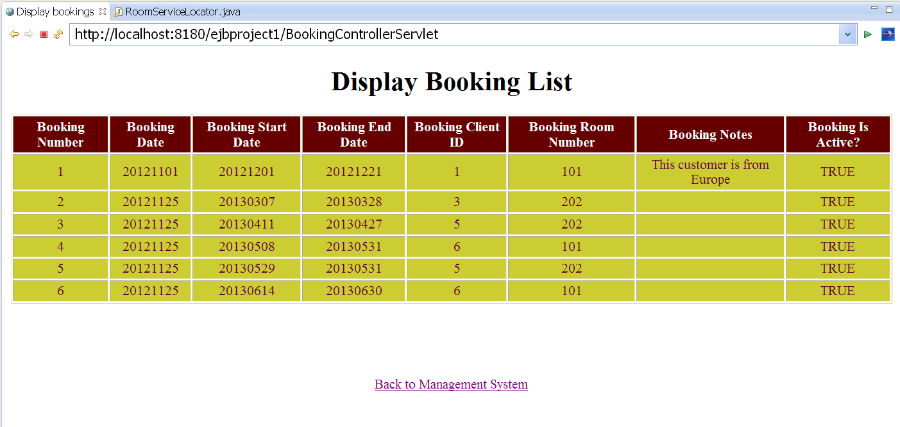

Notice the “Booking is active” column in the booking list. If a client cancelled the booking, it’s better to keep the record and set the “Booking is active” column to “FALSE”. Then when we search all the active bookings, these cancelled bookings will not be counted in. I did this by using method “public List<Booking> listActiveBookings()”:

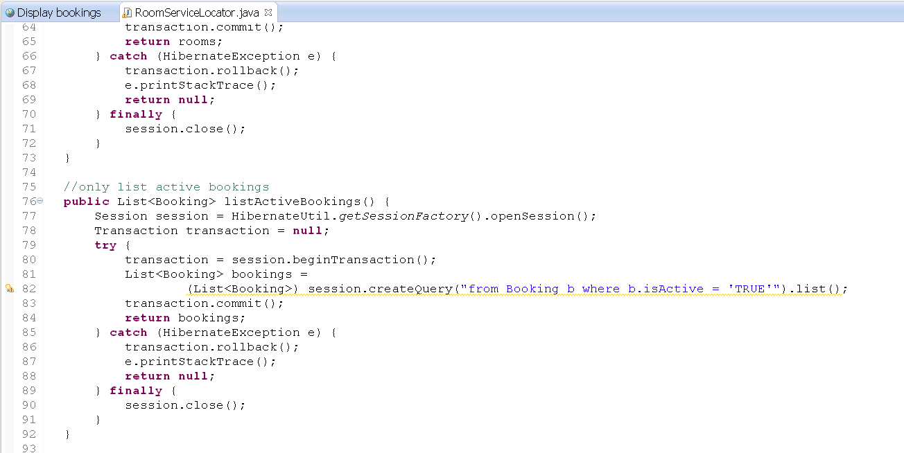

Finally check out our room list:

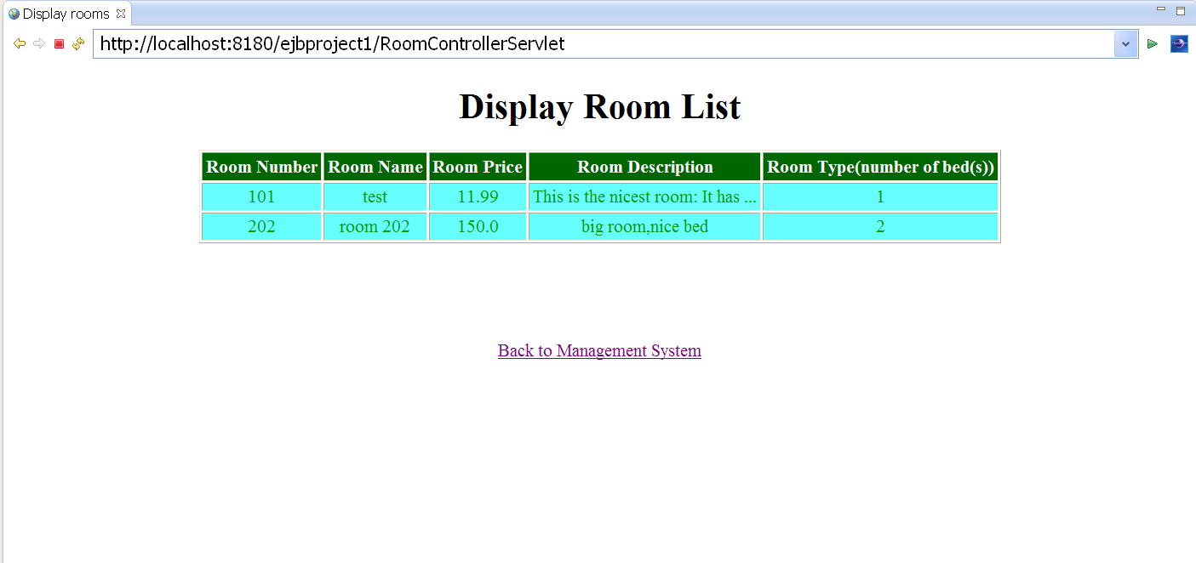

Here is the add room screen. You can choose 4 room types: 1 bed in the room, 2 beds in the room, 3 beds in the room, and 4 beds in the room.

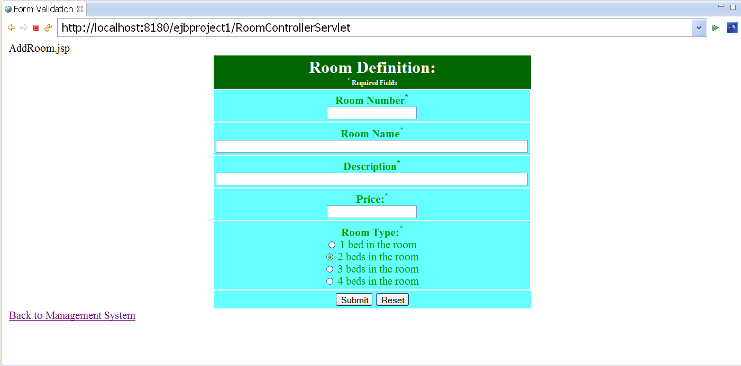

If I forgot to enter room number, price, room name or description, there will be error messages:

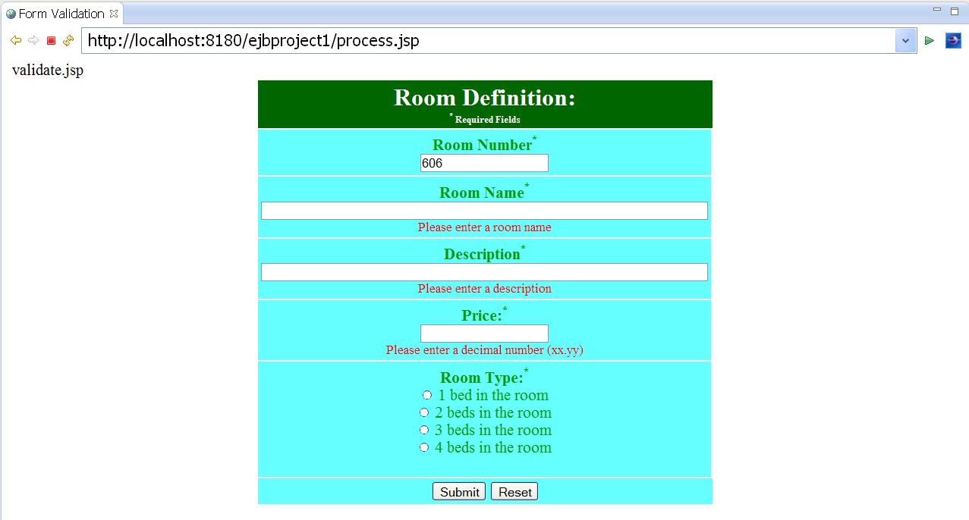

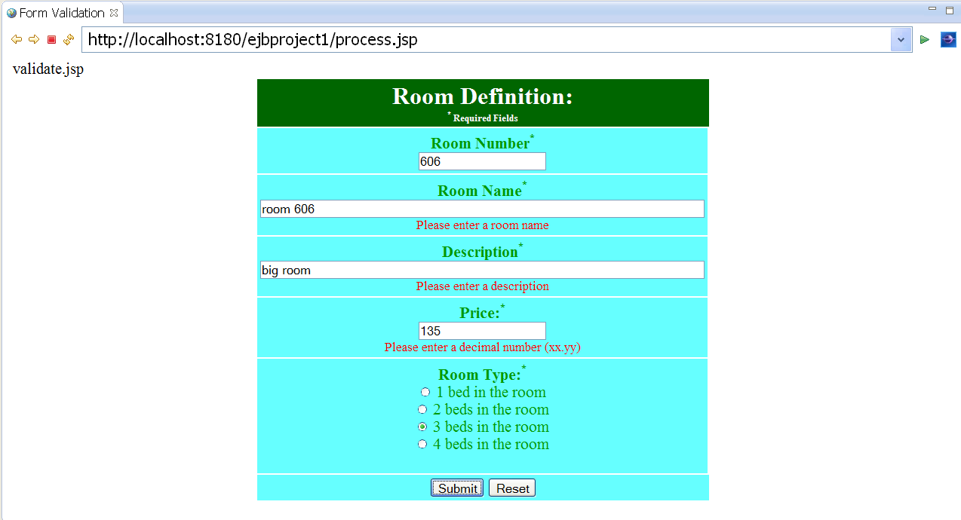

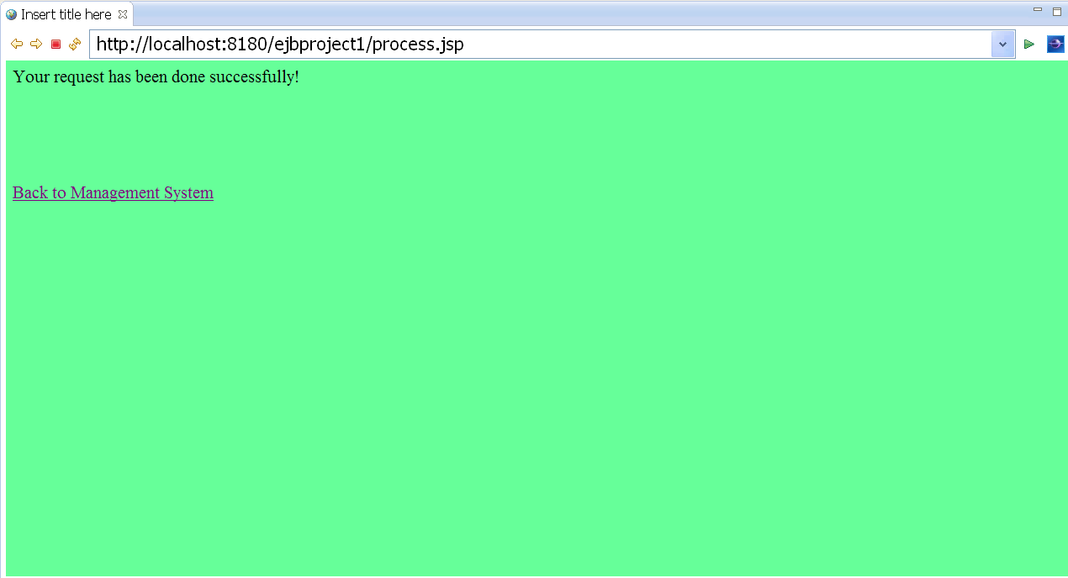

Check the room list:

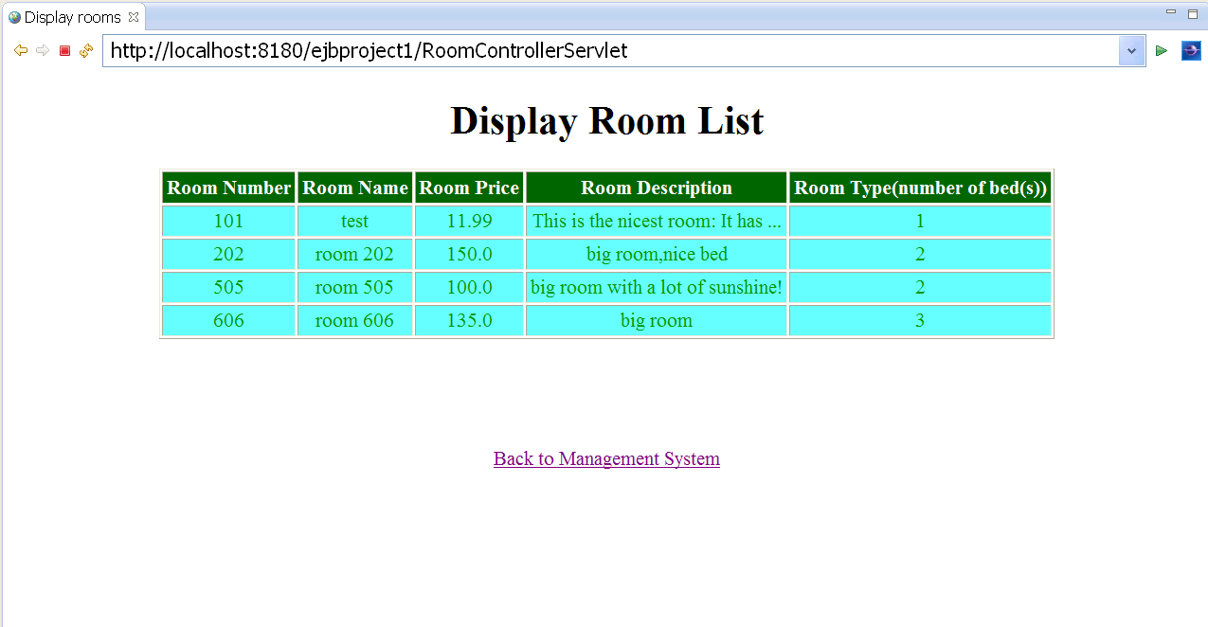

You can aslo use a filter to get the filtered data.

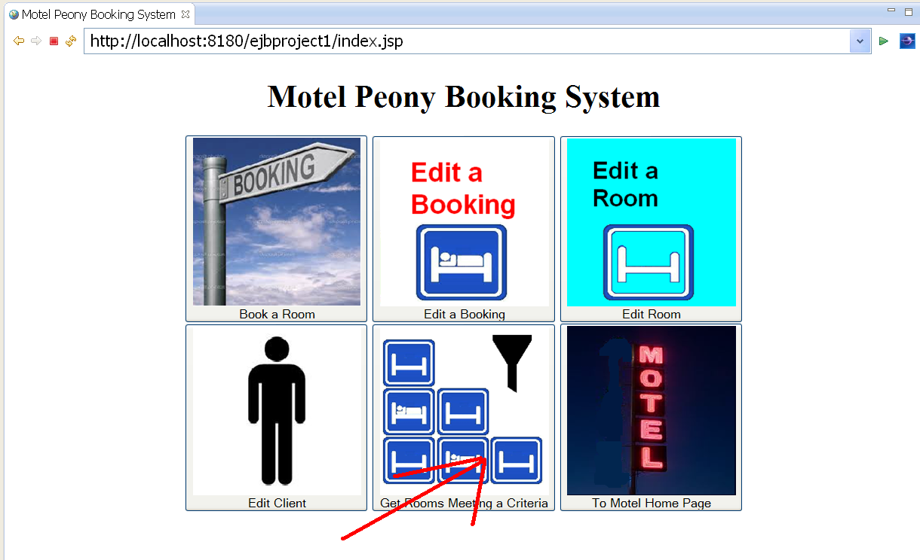

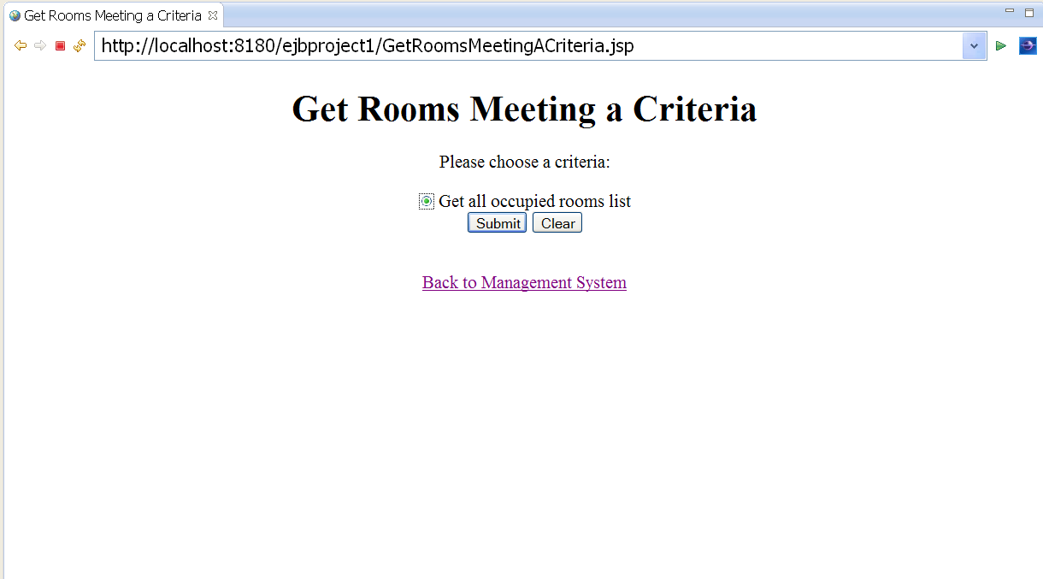

Then you will see the room list.

Finally, you can browse the motel facilities, activities, services, internet, parking and motel policies:

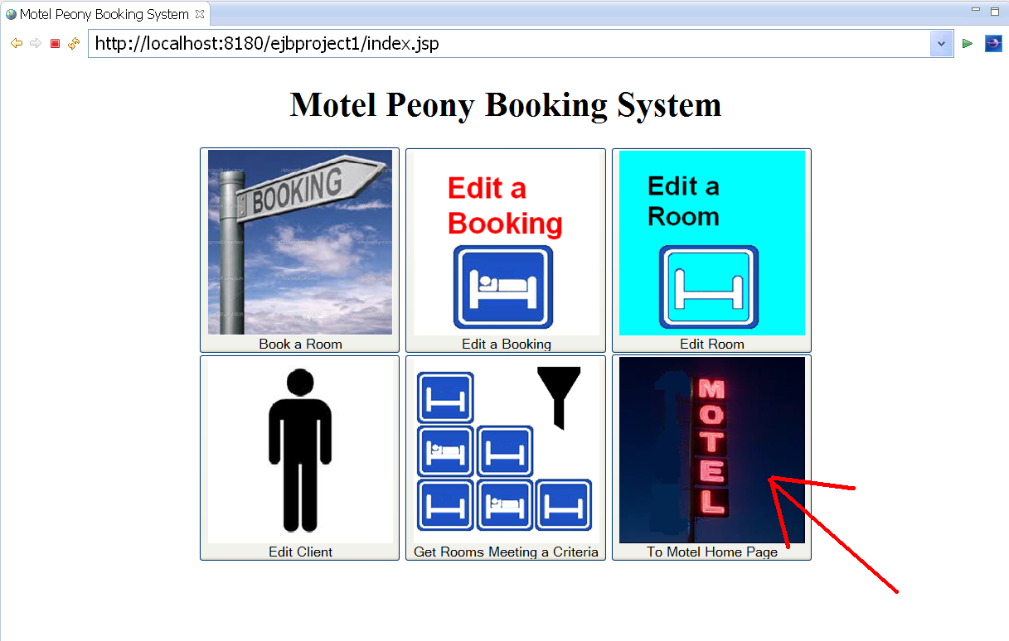

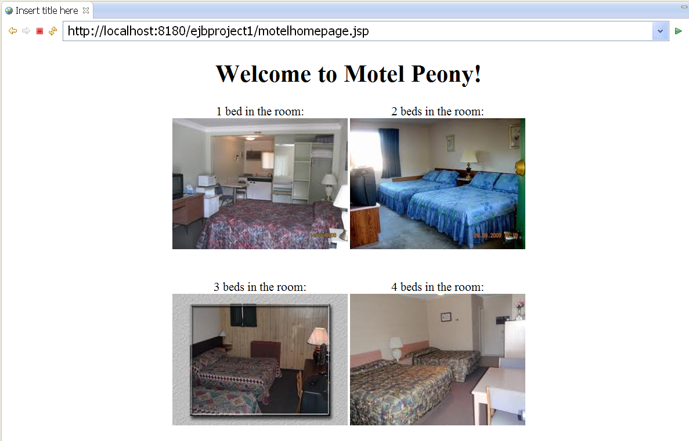

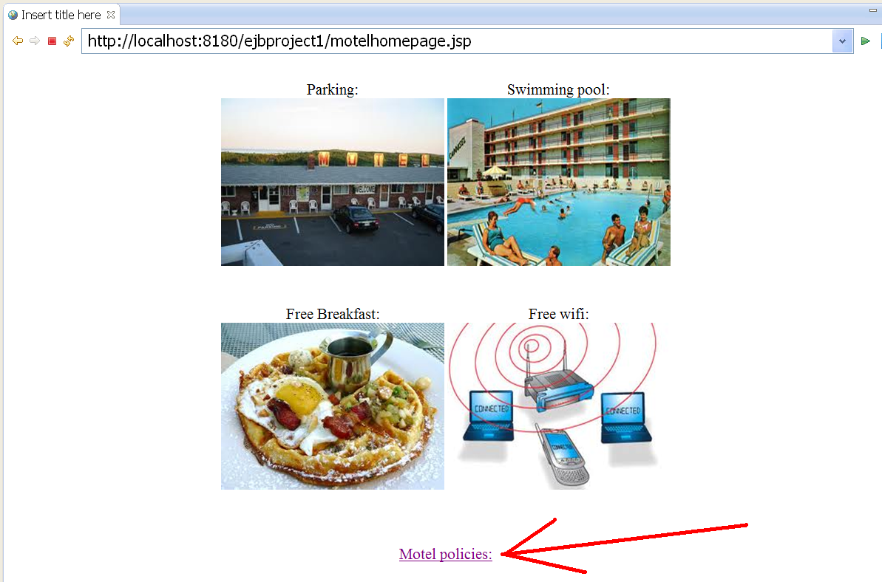

Click “Motel policies” and you will see the policies:

